Company letterhead

(MUST be issued by the supplier of the goods and MUST include the company’s name AND address)

SUPPLIER ZERO ASBESTOS DECLARATION

Regulation 4C, Customs (Prohibited Imports) Regulations 1956

Section 233(1), 1AA Customs Act 1901

ACN 2016/30 - https://www.border.gov.au/Customsnotices/Documents/2016-30.pdf

We, INSERT SUPPLIERS NAME, certify that all goods supplied to INSERT IMPORTERS NAME contain zero asbestos and zero asbestos containing materials.

INSERT SUPPLIERS NAME, confirms

- That asbestos and materials with asbestos content are prohibited imports into Australia.

- We are aware that Australia Border Force (ABF) can still request supporting documentary evidence of testing by National Association of Testing Authorities (NATA).

- We confirm we have read Australian Customs Notice 2016/30 & understand it’s requirements.

4. We will advise INSERT IMPORTERS NAME immediately should the zero asbestos content of imported goods change and we will conduct regular quality assurance checks.

This declaration remains in force until otherwise advised in writing.

Signature: Printed Name:

Date of issue:

(DD/MM/YYYY)

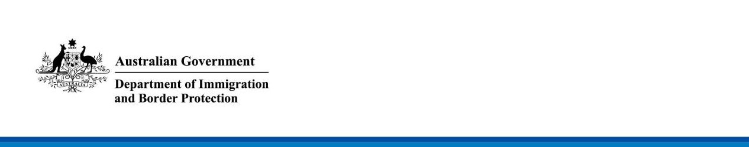

DEPARTMENT OF IMMIGRATION AND BORDER PROTECTION NOTICE

No. 2016/30
Assurances that imported goods do not contain asbestos
The purpose of this notice is to clarify the assurances that importers need to provide and demonstrate to the Australian Border Force (ABF) that goods imported into Australia do not contain asbestos. This notice also provides clarification for licensed customs brokers (LCBs) in declaring these assurances on behalf of their clients.

Background
Since 31 December 2003, an Australia wide ban on the importation, manufacture and use of asbestos and products containing asbestos has been in place. In Australia, a product containing asbestos is prohibited for importation without prior permission under Regulation 4C of the Customs (Prohibited Imports) Regulations 1956.

Under sections 233(1) and (1AA) of the Customs Act 1901 it is an offence to import a prohibited good. Prohibited imports that arrive at the Australian border may be seized and the importer may be prosecuted or subject to penalties.

The Department of Immigration and Border Protection (the Department) proactively manages the risk of asbestos-containing products from entering into Australia. Since its establishment, the ABF has significantly increased its operational and strategic focus on imported goods that pose a risk of containing asbestos. The ABF employs a risk based intelligence-led approach to target these high- risk goods.

Importers

It is the responsibility of importers to ensure that they do not import prohibited goods, including asbestos. Traders need to be aware of the varying definitions and standards applied to goods in the country of origin and / or supply, as some countries allow goods to contain low levels of asbestos.

Before goods are imported to Australia, importers should ensure their supply chain security by confirming with their overseas suppliers that asbestos was not used to manufacture the goods. Importers are encouraged to investigate, and where appropriate implement:

- contractual obligations with their suppliers that specify nil asbestos content;
- sampling and testing for asbestos content prior to shipping the goods to Australia; and
- regular risk assessment and quality assurance processes.

Importers must provide sufficient assurance to demonstrate that imported goods do not contain asbestos. One of the ways importers can provide assurance is through sampling and testing of goods by an accredited laboratory. Certification of samples tested outside Australia must be from a laboratory that is accredited by international accreditation authorities (that are National Association of Testing Authorities (NATA)-recognised equivalents). Any other certificates or statements provided by manufacturers or third parties will not be accepted by the ABF.

In some instances, further assurances will be required through Community Protection Questions (CPQs) for full import declarations in the Integrated Cargo System to confirm that imported goods do not contain asbestos.

If the ABF suspects that imported goods contain asbestos, these goods will be held at the border for further testing. In Australia, the ABF requires testing by a NATA accredited laboratory to certify that the goods do not contain asbestos.

Licensed customs brokers (LCBs)

LCBs must have an understanding of Australia’s import prohibitions. The ABF will continue to support LCBs in educating their clients regarding Australia’s asbestos import prohibition, including sampling, testing and certification requirements.

LCBs are encouraged to exercise due diligence to ensure that the information that they report to the ABF on behalf of their clients is correct. This includes seeking further assurances from importers that imported goods do not contain asbestos prior to responding to asbestos CPQs. This reflects the standard obligation for LCBs in declaring accurate information to the ABF.

When answering the asbestos CPQs, it would be appropriate for LCBs to nominate a “no” response (declaring that the goods do not contain asbestos), if they are satisfied that their clients (and / or suppliers) have provided sufficient assurances. If LCBs consider that sufficient assurances have not been provided, it would be appropriate to nominate a “yes” response (declaring that the goods do contain asbestos) to the asbestos CPQ. It would be appropriate for LCBs to nominate a “yes” response to the asbestos CPQ if they have doubts about the information that has been provided by their clients.

Further information
- Further information about Australia’s asbestos import prohibition is located on the Department’s website at http://www.border.gov.au/Busi/Impo/Proh/Asbestos.

[signed] [signed]

Erin Dale Jane McClintock
Commander Acting Assistant Secretary
Customs Compliance Branch Trade and Customs Branch
Canberra ACT Canberra ACT
8 September 2016 8 September 2016

